Report of Terrestrial Multisensor Systems Lab1
NAME: WANG Zhenqiao
Student ID: 3371590
Data: Labjack
- Introduction
The data acquisition method is determined by the sensor signal (analogue voltage or digital signal). In this lab, we use Optical Speed Sensor. The task is to read the data line by line in a specific time interval. And the output is velocity and the corresponding timestamp.
- Procedure
- Use “Read From Spreadsheet File VI” to input data.
- I choose “For loop” to read data line by line and put them in an array.
- In this array, I read the fourth row (velocity) of each line.
- The velocity is stored in a new array with the corresponding timestamp, then I create an indicator to present them.
- The time is controlled with a “wait function”. I read every 100ms and convert it into a string.
- I use “add” function to count how many iteration it runs, and this is also showed with an indicator.
- At last, I use “Write To Spreadsheet File VI” to output my data to a txt file.

- flowchart
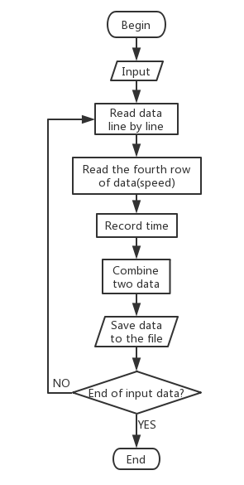

- Results
The followings are my results:
